**Digital Electronics Project**

Topic:Digital stop watch (60 seconds)

**Done by:**

**AP20110010083 – Rohitha Venkata Naga Sai Sidda**

**AP20110010111 – Venkata Krishna Priya Gurram**

**AP20110010115 – Viswasri Kolli**

**AP20110010120 – Prameela Nannapaneni**

**AP20110010126 – Jyothika Reddy Palli**

**Objective:** To make a digital stopwatch that can count till 60 seconds.

**Theory:**

We are creating a stopwatch using mod-6 counter, mod-10 counter and bcd to 7 segment display decoder. mod 6 counter is used for the first digit and mod 10 for the second digit. Since the output comes in bcd form, we use bcd to 7 seven segment display decoder to display the output.

**Mod - 10 Synchronous Counter using JK flip-flop:**

Here mod - 10 counter has no. of states =10

No. of flip flops (FF): N≤2n => 10<2n so, n= 4

**State Diagram:**

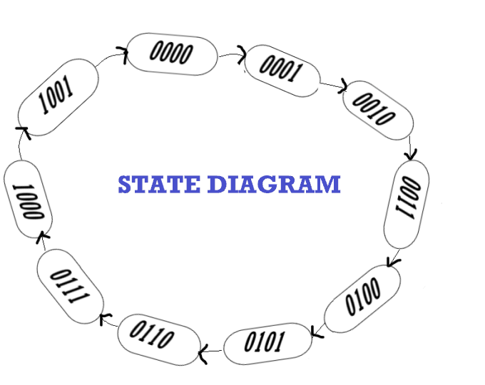

**State Table:**



|  |  |  |  |  |  |  |  |  |  |  |  |  |  |  |  |  |  |  |
| --- | --- | --- | --- | --- | --- | --- | --- | --- | --- | --- | --- | --- | --- | --- | --- | --- | --- | --- |
| **\*** | | | **Present Sate** | | | | **Next State** | | | | **INPUTS OF FF** | | | | | | | |
| **S**.NO | | | **QA** | **QB** | **QC** | **QD** | **QA+1** | **QB+1** | **QC+1** | **QD+1** | JA | KA | JB | KB | JC | KC | JD | KD |
| **0.** | | | **0** | **0** | **0** | **0** | **0** | **0** | **0** | **1** | **0** | **X** | **0** | **X** | **0** | **X** | **1** | **X** |
| **1.** | | **0** | | **0** | **0** | **1** | **0** | **0** | **1** | **0** | **0** | **X** | **0** | **X** | **1** | **X** | **X** | **1** |
| **2.** | | **0** | | **0** | **1** | **0** | **0** | **0** | **1** | **1** | **0** | **X** | **0** | **X** | **X** | **0** | **1** | **X** |
| **3.** | | **0** | | **0** | **1** | **1** | **0** | **1** | **0** | **0** | **0** | **X** | **1** | **X** | **X** | **1** | **X** | **1** |
| **4.** | | **0** | | **1** | **0** | **0** | **0** | **1** | **0** | **1** | **0** | **X** | **X** | **0** | **0** | **X** | **1** | **X** |
| **5.** | | **0** | | **1** | **0** | **1** | **0** | **1** | **1** | **0** | **0** | **X** | **X** | **0** | **1** | **X** | **X** | **1** |
| **6.** | | **0** | | **1** | **1** | **0** | **0** | **1** | **1** | **1** | **0** | **X** | **X** | **0** | **X** | **0** | **1** | **X** |
| **7.** | **0** | | | **1** | **1** | **1** | **1** | **0** | **0** | **0** | **1** | **X** | **X** | **1** | **X** | **1** | **X** | **1** |
| **8.** | **1** | | | **0** | **0** | **0** | **1** | **0** | **0** | **1** | **X** | **0** | **0** | **X** | **0** | **X** | **1** | **X** |
| **9.** | **1** | | | **0** | **0** | **1** | **0** | **0** | **0** | **0** | **X** | **1** | **0** | **X** | **0** | **X** | **X** | **1** |
| **10.** | **1** | | | **0** | **1** | **0** | **X** | **X** | **X** | **X** | **X** | **X** | **X** | **X** | **X** | **X** | **X** | **X** |
| **11.** | **1** | | | **0** | **1** | **1** | **X** | **X** | **X** | **X** | **X** | **X** | **X** | **X** | **X** | **X** | **X** | **X** |
| **12.** | **1** | | | **1** | **0** | **0** | **X** | **X** | **X** | **X** | **X** | **X** | **X** | **X** | **X** | **X** | **X** | **X** |
| **13.** | **1** | | | **1** | **0** | **1** | **X** | **X** | **X** | **X** | **X** | **X** | **X** | **X** | **X** | **X** | **X** | **X** |
| **14.** | **1** | | | **1** | **1** | **0** | **X** | **X** | **X** | **X** | **X** | **X** | **X** | **X** | **X** | **X** | **X** | **X** |
| **15.** | **1** | | | **1** | **1** | **1** | **X** | **X** | **X** | **X** | **X** | **X** | **X** | **X** | **X** | **X** | **X** | **X** |

**K - Maps:**

|  |  |  |  |  |
| --- | --- | --- | --- | --- |
|  | **QC’QD’** | **QC’QD** | **QCQD** | **QCQD’** |
| **QA’QB’** |  |  |  |  |
| **QA’QB** |  |  | 1 |  |
| **QAQB** | X | X | X | X |
| **QAQB’** | X | X | X | X |

|  |  |  |  |  |
| --- | --- | --- | --- | --- |
|  | **QC’QD’** | **QC’QD** | **QCQD** | **QCQD’** |
| **QA’QB’** | X | X | X | X |
| **QA’QB** | X | X | X | X |
| **QAQB** | X | X | X | X |
| **QAQB’** |  | 1 | X | X |

JA = QBQCQD KA = **QD**

|  |  |  |  |  |
| --- | --- | --- | --- | --- |
|  | **QC’QD’** | **QC’QD** | **QCQD** | **QCQD’** |
| **QA’QB’** |  |  | 1 |  |
| **QA’QB** | X | X | X | X |
| **QAQB** | X | X | X | X |
| **QAQB’** |  |  | X | X |

|  |  |  |  |  |
| --- | --- | --- | --- | --- |
|  | **QC’QD’** | **QC’QD** | **QCQD** | **QCQD’** |
| **QA’QB’** | X | X | X | X |
| **QA’QB** |  |  | 1 |  |
| **QAQB** | X | X | X | X |
| **QAQB’** | X | X | X | X |

JB = QCQD KB = QCQD

|  |  |  |  |  |
| --- | --- | --- | --- | --- |
|  | **QC’QD’** | **QC’QD** | **QCQD** | **QCQD’** |
| **QA’QB’** |  | 1 | X | X |
| **QA’QB** |  | 1 | X | X |
| **QAQB** | X | X | X | X |
| **QAQB’** |  |  | X | X |

|  |  |  |  |  |
| --- | --- | --- | --- | --- |
|  | **QC’QD’** | **QC’QD** | **QCQD** | **QCQD’** |
| **QA’QB’** | X | X | 1 |  |
| **QA’QB** | X | X | 1 |  |
| **QAQB** | X | X | X | X |
| **QAQB’** | X | X | X | X |

JC = QA' QD KC = QD

|  |  |  |  |  |
| --- | --- | --- | --- | --- |
|  | **QC’QD’** | **QC’QD** | **QCQD** | **QCQD’** |
| **QA’QB’** | X | 1 | X | 1 |
| **QA’QB** | X | 1 | X | 1 |
| **QAQB** | X | X | X | X |
| **QAQB’** | X | 1 | X | X |

|  |  |  |  |  |
| --- | --- | --- | --- | --- |
|  | **QC’QD’** | **QC’QD** | **QCQD** | **QCQD’** |
| **QA’QB’** | 1 | X | X | 1 |
| **QA’QB** | 1 | X | X | 1 |
| **QAQB** | X | X | X | X |
| **QAQB’** | 1 | X | X | X |

JD = 1 KD =1

**Equations:** JA = QBQCQDKA = QD

JB = QCQD KB = QCQD

JC = QA’QD KC = QD JD = KD =1

**Circuit Diagram:**

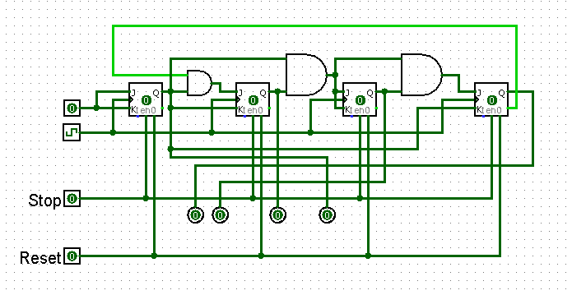

Here, the count increases only when stop is 1. The input should be 1 as we have seen in the equations. If reset is 1, the count comes to 0. The above circuit should be modified on these values to give output.

**Mod - 6 Synchronous Counter using JK flip-flop:**

Here mod - 6 counter has no. of states = 6

No. of flip flops (FF): N≤2n => 6<2n so, n = 3

**State Diagram:**

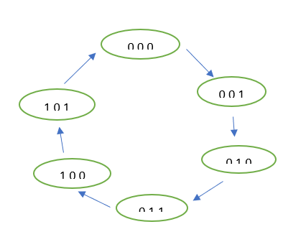

**State Table:**

Present state Next state Inputs of flip-flop

|  |  |  |  |  |  |  |  |  |  |  |  |
| --- | --- | --- | --- | --- | --- | --- | --- | --- | --- | --- | --- |
| QA | QB | QC | Q(A+1) | Q(B+1) | Q(C+1) | JA | KA | JB | KB | JC | Kc |
| 0 | 0 | 0 | 0 | 0 | 1 | 0 | x | 0 | x | 1 | x |
| 0 | 0 | 1 | 0 | 1 | 0 | 0 | x | 1 | x | x | 1 |
| 0 | 1 | 0 | 0 | 1 | 1 | 0 | x | x | 0 | 1 | x |
| 0 | 1 | 1 | 1 | 0 | 0 | 1 | x | x | 1 | x | 1 |
| 1 | 0 | 0 | 1 | 0 | 1 | x | 0 | 0 | x | 1 | x |
| 1 | 0 | 1 | 0 | 0 | 0 | x | 1 | 0 | x | x | 1 |
| 1 | 1 | 0 | x | x | x | x | x | x | x | x | x |
| 1 | 1 | 1 | x | x | x | x | x | x | x | x | x |

**K - Maps:**

QB’QC’ QB’QC QBQC QBQC’ QB’QC’ QB’QC QBQC QBQC’

|  |  |  |  |
| --- | --- | --- | --- |
|  |  | 1 |  |
| x | x | X | x |

|  |  |  |  |
| --- | --- | --- | --- |
| x | x | x | x |
|  | X | 1 |  |

QA

QA’

JA = QBQc KA = Qc

QB’Qc’ QB’Qc QBQc QBQc’ QB’Qc’ QB’Qc QBQc QBQc’

|  |  |  |  |
| --- | --- | --- | --- |
|  | 1 | x | x |
|  | 1 | x | x |

|  |  |  |  |
| --- | --- | --- | --- |
| x | x | 1 |  |
|  | x | x | x |

QA

QA’

JB = QA’Qc KB = Qc

QB’Qc’ QB’Qc QBQc QBQc’ QB’Qc’ QB’Qc QBQc QBQc’

|  |  |  |  |
| --- | --- | --- | --- |
| 1 | x | x | 1 |
| 1 | x | x | x |

|  |  |  |  |
| --- | --- | --- | --- |
| x | 1 | 1 | x |
| x | 1 | x | x |

QA

QA’

Jc = 1 Kc=1

**Equations:** JA = QBQc KA = Qc

JB = QA’Qc KB = QcJc = Kc = 1

**Circuit Diagram:**

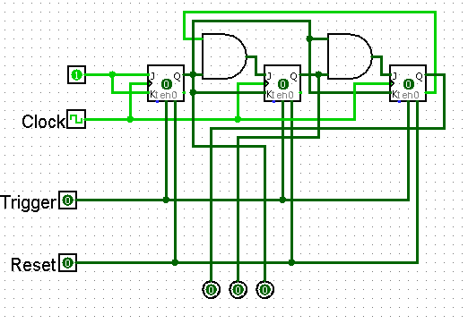

Here, the count increases only when trigger is 1. The input should be 1 as we have seen in the equations. If reset is 1, the count comes to 0. The above circuit should be modified on these values to give output.

**7 segment LED display:**

|  |  |  |  |  |  |  |  |  |  |  |  |  |
| --- | --- | --- | --- | --- | --- | --- | --- | --- | --- | --- | --- | --- |
| Digit | A | B | C | D | a | b | c | d | e | f | g | dp |
| 0 | 0 | 0 | 0 | 0 | 1 | 1 | 1 | 1 | 1 | 1 | 0 | 0 |
| 1 | 0 | 0 | 0 | 1 | 0 | 1 | 1 | 0 | 0 | 0 | 0 | 0 |
| 2 | 0 | 0 | 1 | 0 | 1 | 1 | 0 | 1 | 1 | 0 | 1 | 0 |
| 3 | 0 | 0 | 1 | 1 | 1 | 1 | 1 | 1 | 0 | 0 | 1 | 0 |
| 4 | 0 | 1 | 0 | 0 | 0 | 1 | 1 | 0 | 0 | 1 | 1 | 0 |
| 5 | 0 | 1 | 0 | 1 | 1 | 0 | 1 | 1 | 0 | 1 | 1 | 0 |
| 6 | 0 | 1 | 1 | 0 | 1 | 0 | 1 | 1 | 1 | 1 | 1 | 0 |
| 7 | 0 | 1 | 1 | 1 | 1 | 1 | 1 | 0 | 0 | 0 | 0 | 0 |
| 8 | 1 | 0 | 0 | 0 | 1 | 1 | 1 | 1 | 1 | 1 | 1 | 0 |
| 9 | 1 | 0 | 0 | 1 | 1 | 1 | 1 | 1 | 0 | 1 | 1 | 0 |

**K – Maps:**

|  |  |  |  |  |
| --- | --- | --- | --- | --- |
| **a:** | A’B’ | A’B | AB | AB’ |
| C’D’ | 1 | 0 | 1 | 1 |
| C’D | 0 | 1 | 1 | 1 |
| CD | x | x | x | x |
| CD’ | 1 | 1 | x | x |

|  |  |  |  |  |
| --- | --- | --- | --- | --- |
| **b:** | A’B’ | A’B | AB | AB’ |
| C’D’ | 1 | 0 | 1 | 1 |
| C’D | 1 | 0 | 1 | 0 |
| CD | x | x | x | x |
| CD’ | 1 | 1 | x | x |

|  |  |  |  |  |
| --- | --- | --- | --- | --- |
| **c:** | A’B’ | A’B | AB | AB’ |
| C’D’ | 1 | 1 | 1 | 0 |
| C’D | 1 | 1 | 1 | 1 |
| CD | x | x | x | x |
| CD’ | 1 | 1 | x | x |

|  |  |  |  |  |
| --- | --- | --- | --- | --- |
| **d:** | A’B’ | A’B | AB | AB’ |
| C’D’ | 1 | 0 | 1 | 1 |
| C’D | 0 | 1 | 0 | 1 |
| CD | x | x | x | x |
| CD’ | 1 | 1 | x | x |

|  |  |  |  |  |
| --- | --- | --- | --- | --- |
| **e:** | A’B’ | A’B | AB | AB’ |
| C’D’ | 1 | 0 | 0 | 1 |
| C’D | 0 | 0 | 0 | 1 |
| CD | x | x | x | x |
| CD’ | 1 | 0 | x | x |

|  |  |  |  |  |
| --- | --- | --- | --- | --- |
| **f:** | A’B’ | A’B | AB | AB’ |
| C’D’ | 1 | 0 | 0 | 0 |
| C’D | 1 | 1 | 0 | 1 |
| CD | x | x | x | x |
| CD’ | 1 | 1 | x | x |

|  |  |  |  |  |
| --- | --- | --- | --- | --- |
| **g:** | A’B’ | A’B | AB | AB’ |
| C’D’ | 0 | 0 | 1 | 1 |
| C’D | 1 | 1 | 0 | 1 |
| CD | x | x | x | x |
| CD’ | 1 | 1 | x | x |

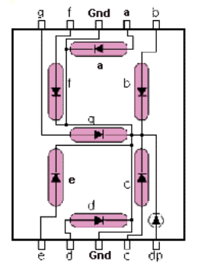**Equations:**

a = A+C+BD+B’D’ b = B’+C’D’+CD

c = B+C’+D d = B’D’+CD’+BC’D+B’C+A

e = B’D’+CD’ f = A+C’D’+BC’+BD’

g = A+BC’+B’C+CD’

**Circuit Diagram:**

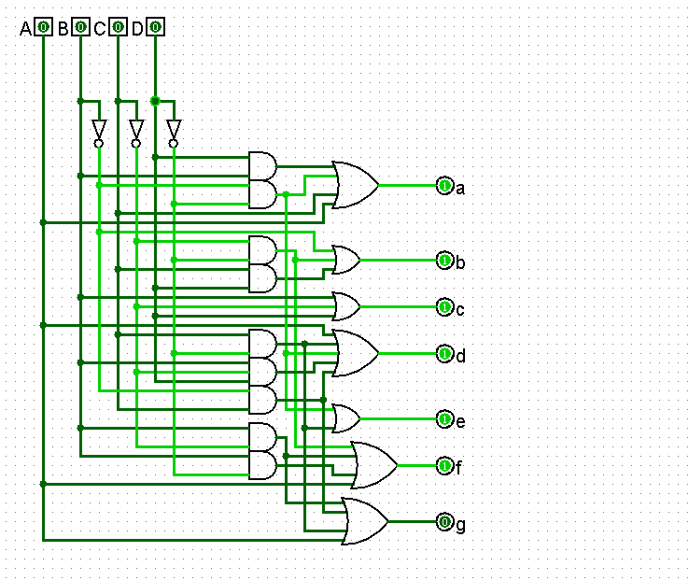

**Digital Stopwatch Circuit Diagram:**

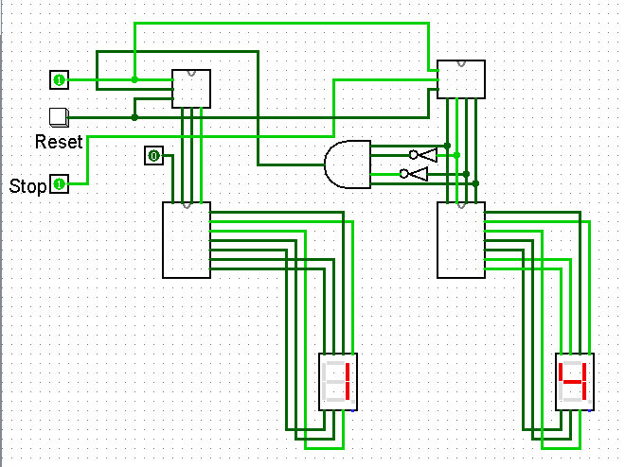

This circuit counts 0-59. Once the reset button is pressed, the count starts from 0 again.

When the input stop is 0, the count stops. Mod 6 counter counts only when the count of mod 10 is 9. This is operated with the help of AND and NOT gates are displayed in the above diagram.

When the count is 9, 1001 is the output of mod 10 counter. Only then, the AND gate gives 1 as output. Until it is 1, the clock pulses do not show any effect on the count in mod 6 counter.

The frequency used for this circuit is 2 Hz. It can further be improved to count for minutes and hours also.